IAM TASK
1. Create one IAM user and assign EC2 and S3 full access roles.
Step 1: Login to AWS Console
Explanation:
Login to AWS using root or admin account to create IAM users.
Step 2: Open IAM Service
Explanation:
IAM is used to manage users, groups, and permissions.
Step 3: Create new user named dev-user
Explanation:
IAM user represents a person or application that needs access.
Step 4: Enable console access
Explanation:
This allows user to login to AWS dashboard.
Step 5: Attach policies AmazonEC2FullAccess and AmazonS3FullAccess
Explanation:
Policies define permissions.
AmazonEC2FullAccess → full control over EC2
AmazonS3FullAccess → full control over S3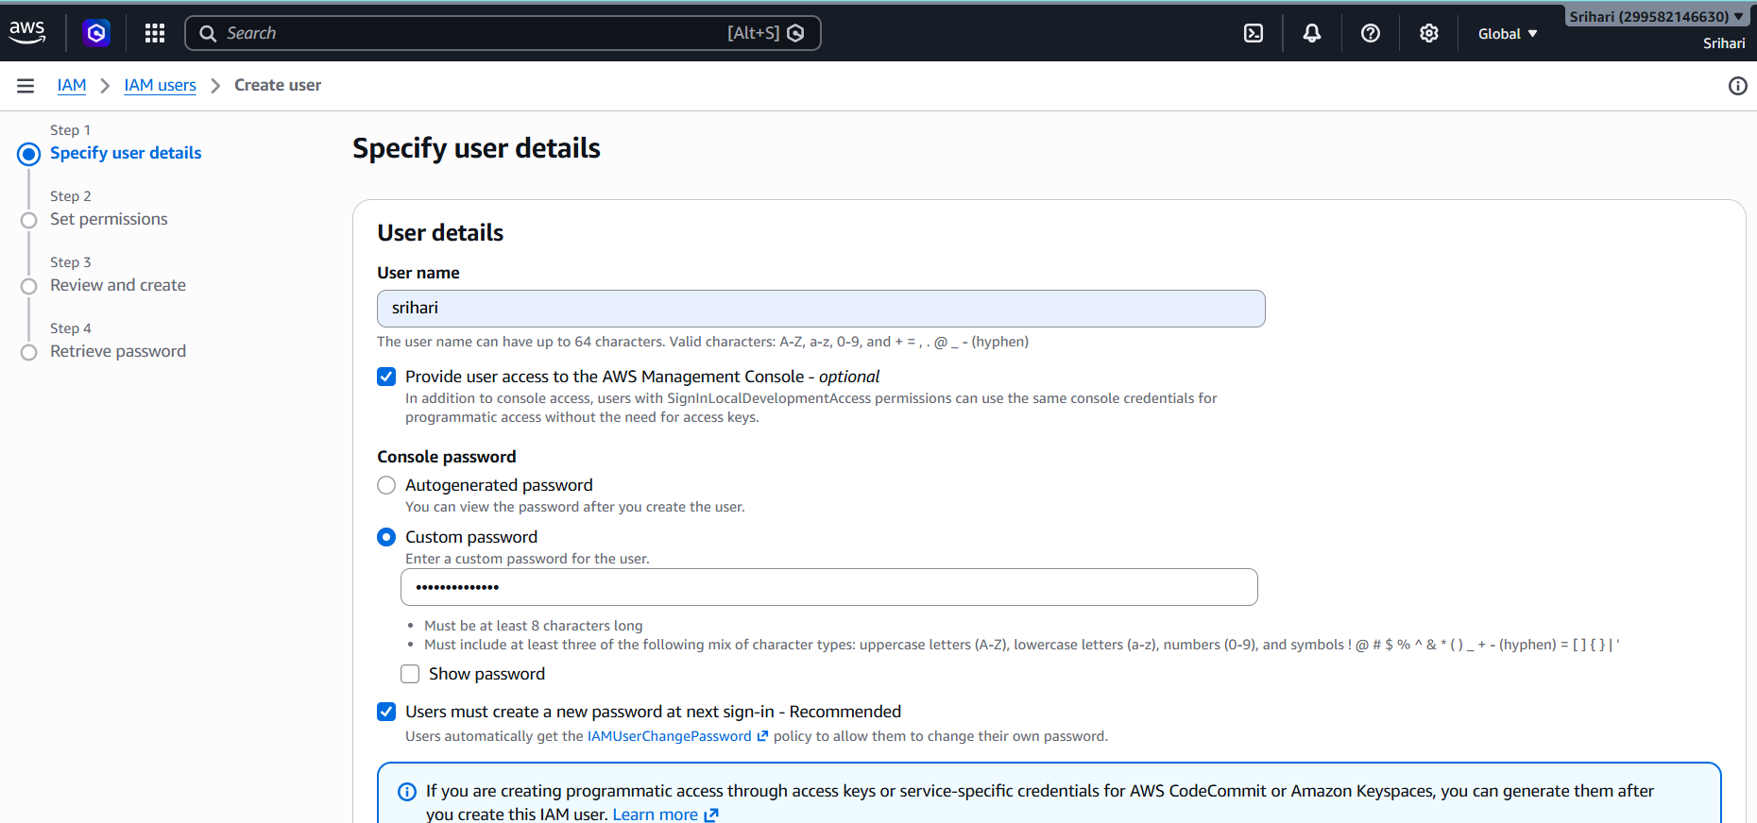

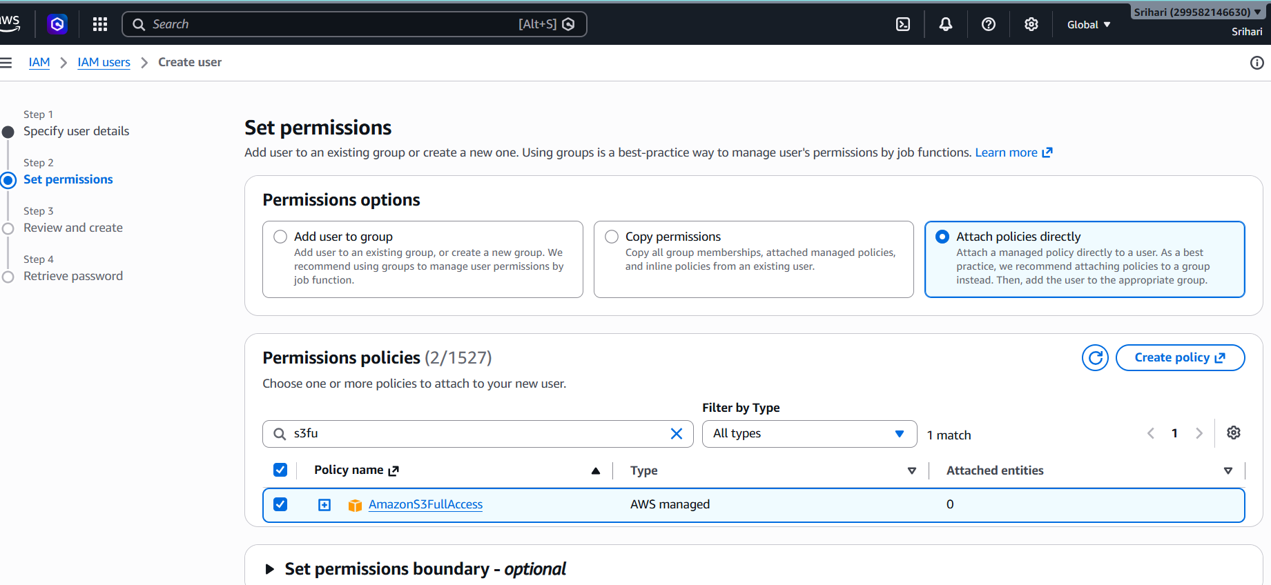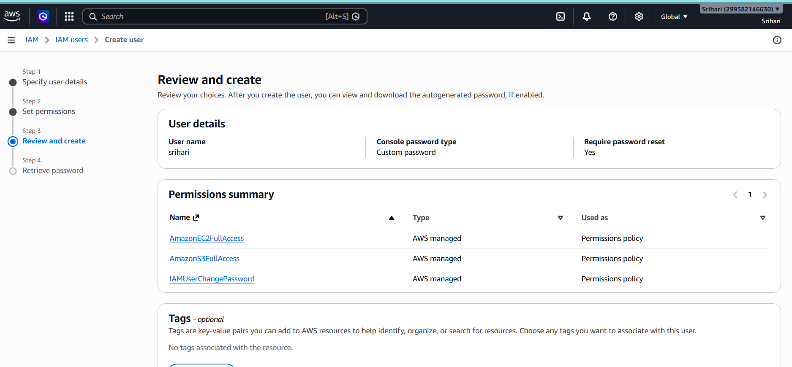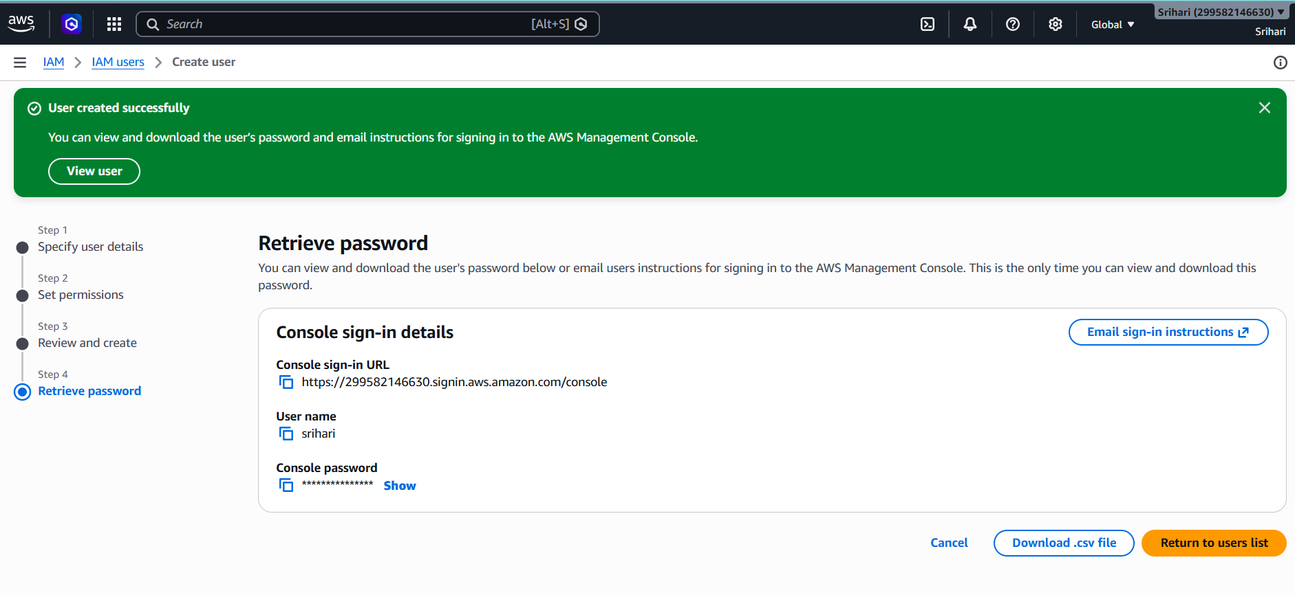

2. Create one group in IAM and assign read access for EC2.
Step 1: Create group EC2-Read-Group
Explanation:
Group is used to manage multiple users with same permissions.
Step 2: Attach policy AmazonEC2ReadOnlyAccess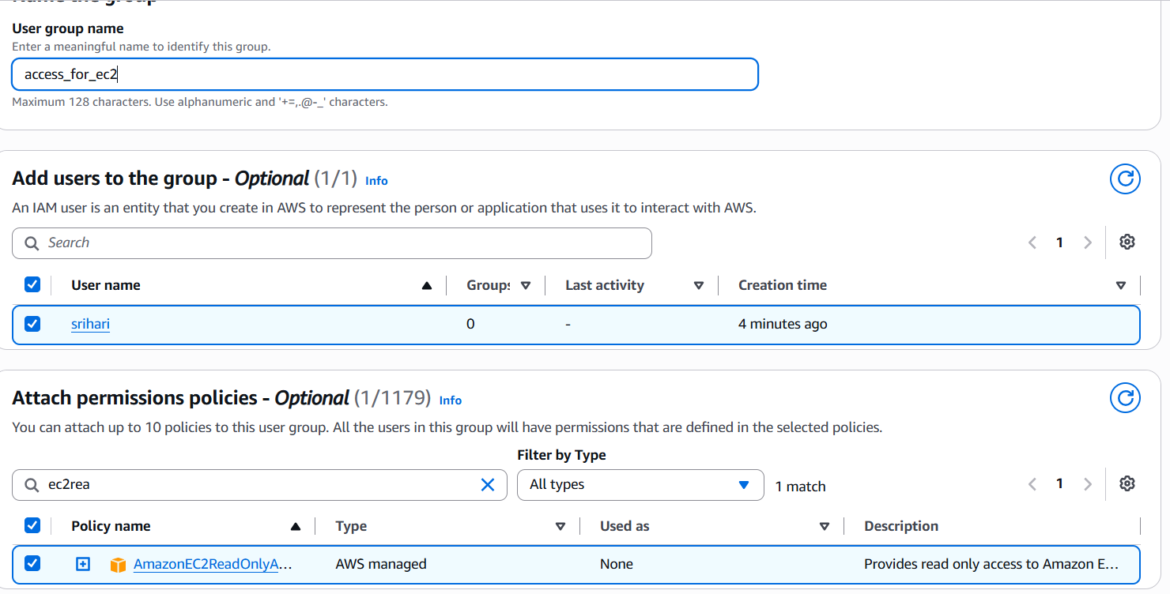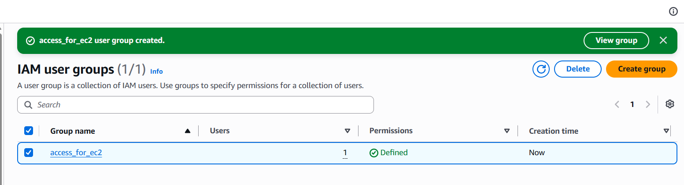
Explanation:
This allows viewing EC2 but not modifying.

3. Create a new user named "Devops" and add to the group created in task 2.
Step 1: Create user Devops
Explanation:
Represents DevOps engineer.
Step 2: Add user to EC2-Read-Group
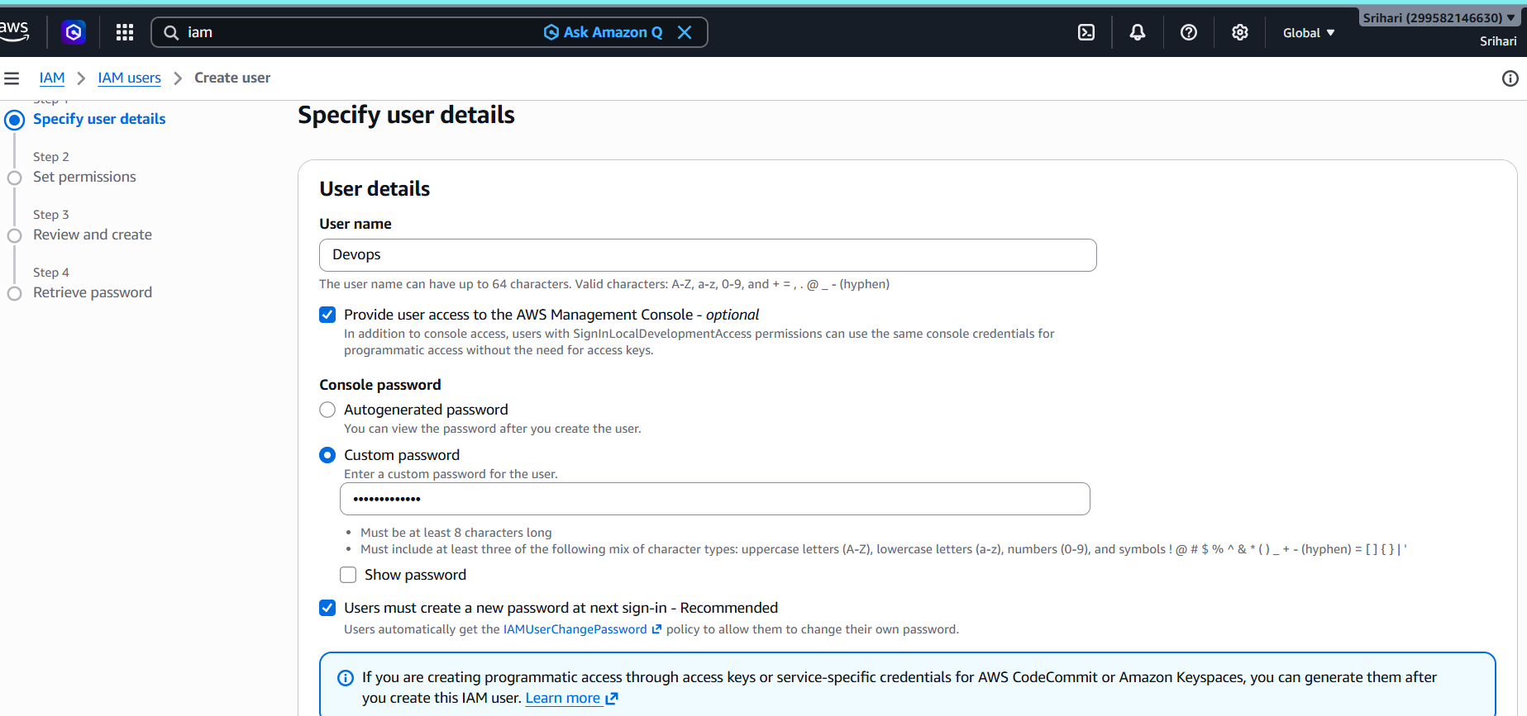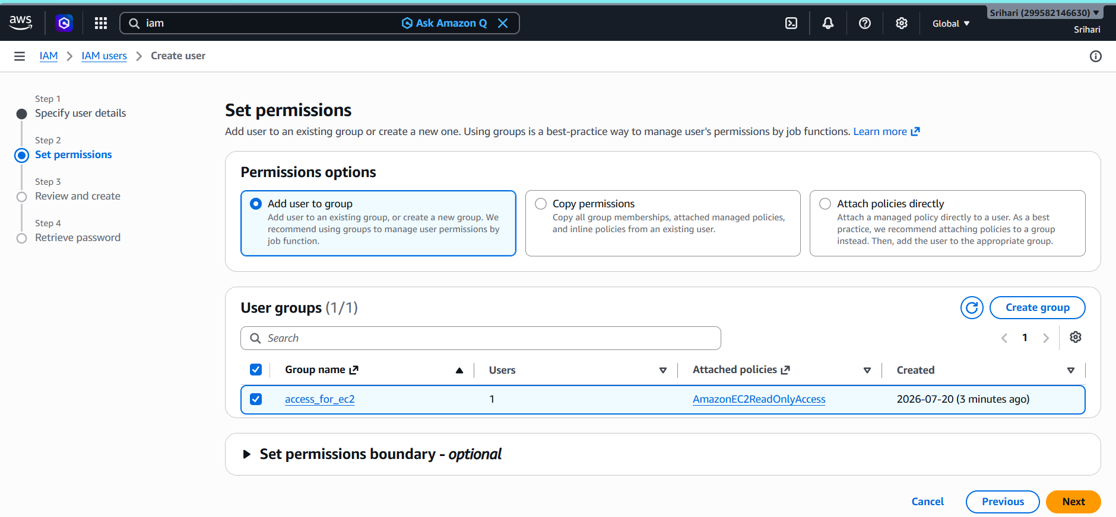
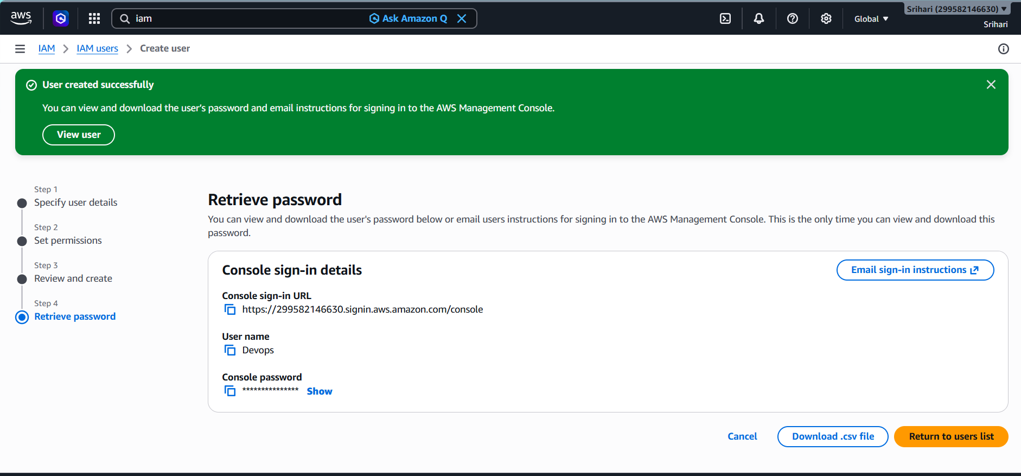 Explanation:
User inherits permissions from group automatically.
4. Write a bash script to create an IAM user with VPC full access.
Step 1: Connect to the EC2 Instance
Connect to your Amazon Linux EC2 instance using SSH.
Step 2: Configure AWS CLI
Configure AWS CLI with your IAM user's credentials.
Step 3: Create the Bash Script
Create a new script file.
Step 4: Provide Execute Permission
chmod 755 IAMrole.bash
Step 5: Execute the Script

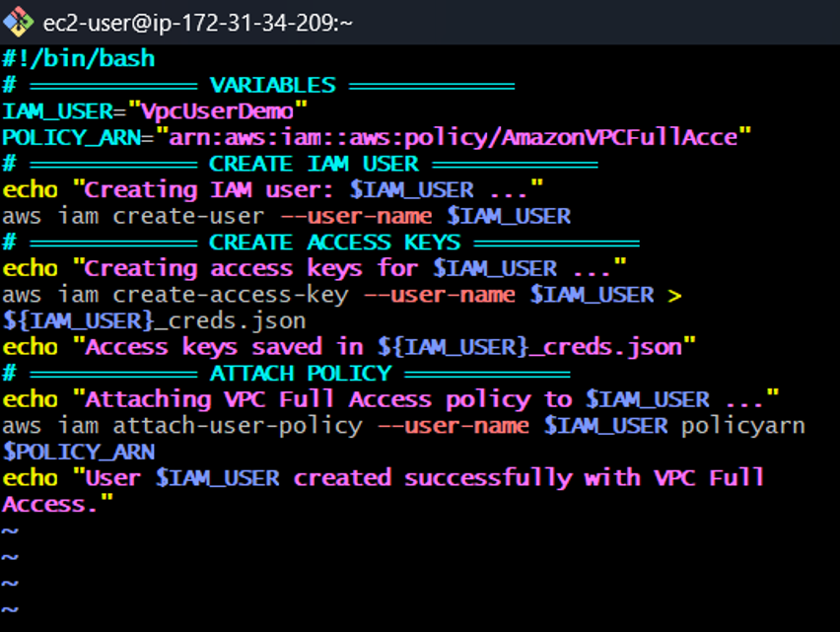
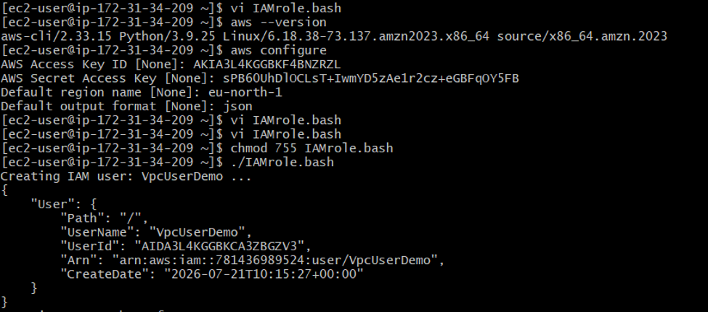

5. Create an IAM policy to allow EC2 access for a specific user in specific regions only.
Step 1: Create new policy using JSON
Explanation:
JSON defines permissions.
Step 2: Restrict region using condition
Explanation:
Allows access only in specific AWS region.
Step 3: Attach policy to user

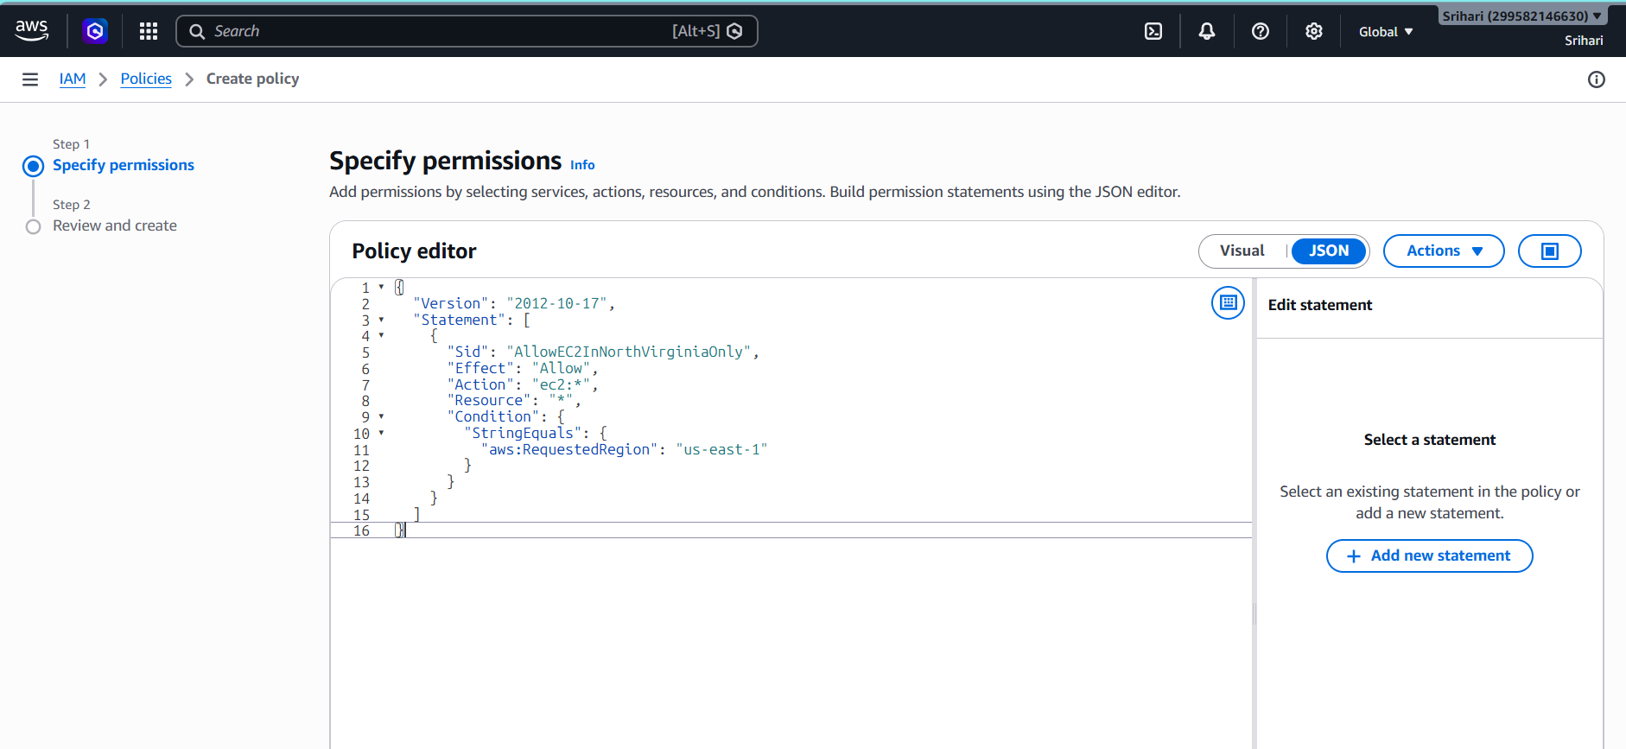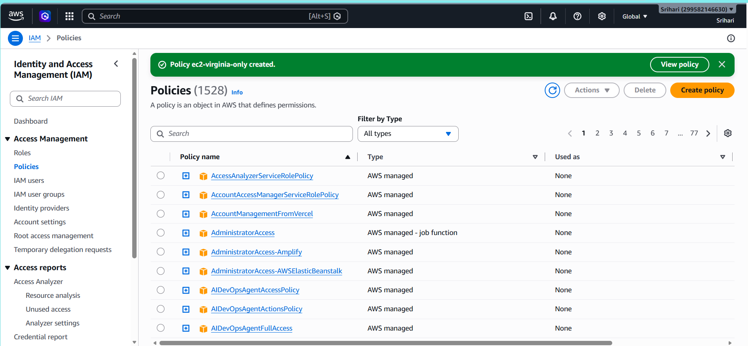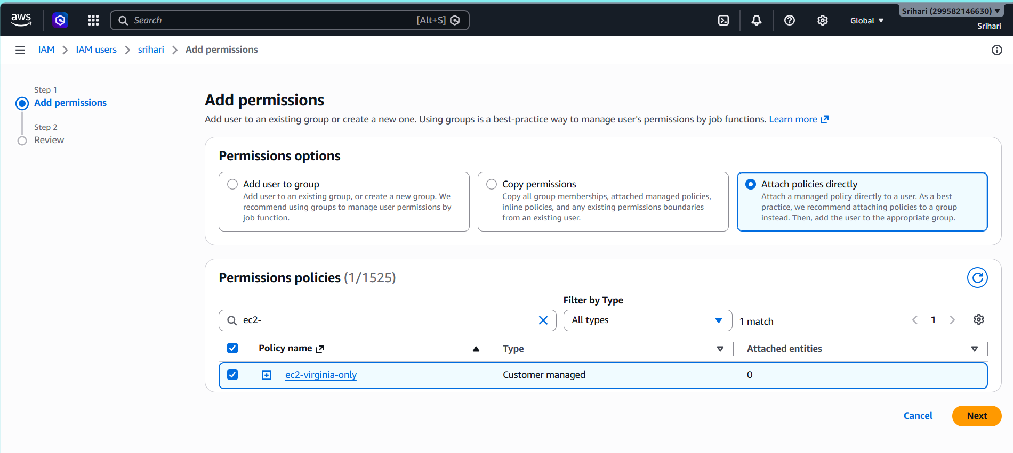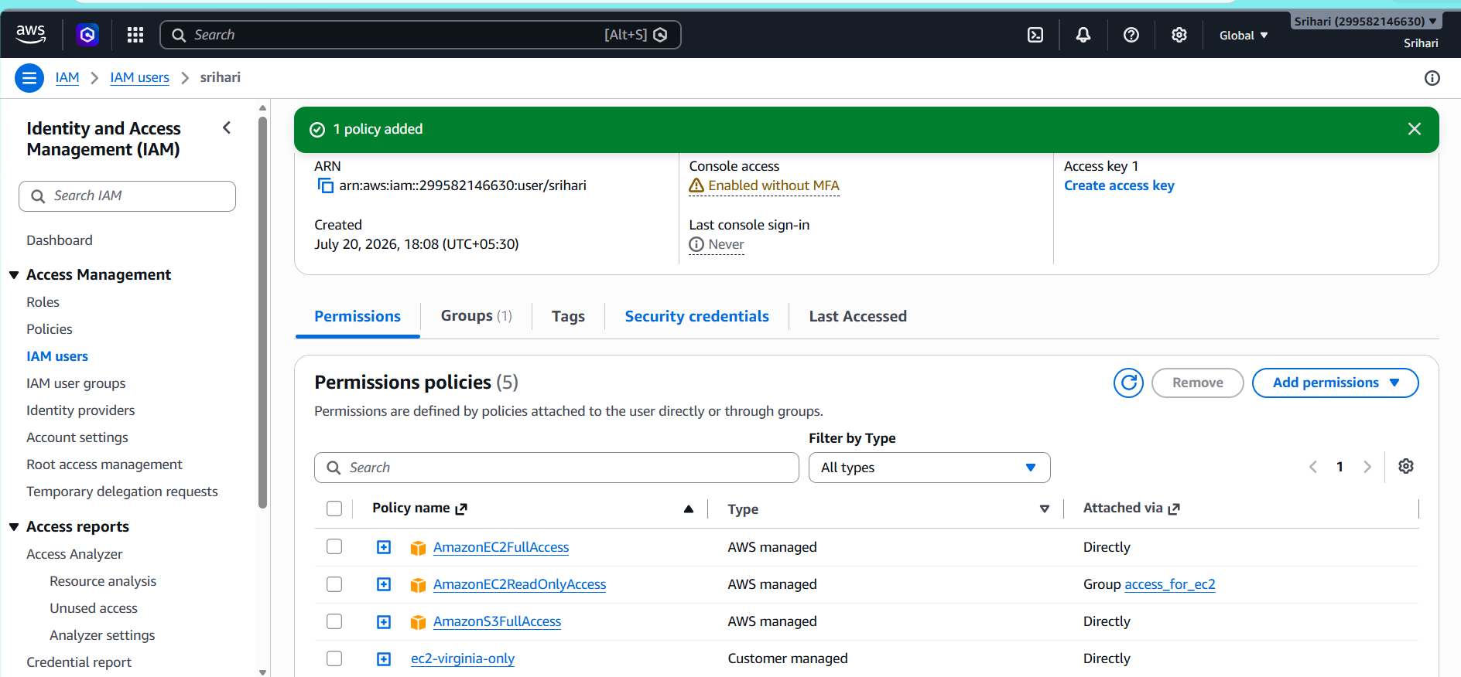
Explanation:
User now can access EC2 only in allowed region

6. We have two accounts: Account A and Account B. Account A user should access an S3 bucket in Account B.
1. Overview
Cross-account role assumption allows one AWS account (Source Account) to access resources in another AWS account (Target Account) securely using IAM roles and temporary credentials.
Example:
Source Account ID: 127521539590
Target Account ID: 708035287026
Role Name: friend-s3-access
Purpose:
This is used when you want to give secure access between different AWS accounts without sharing permanent credentials.
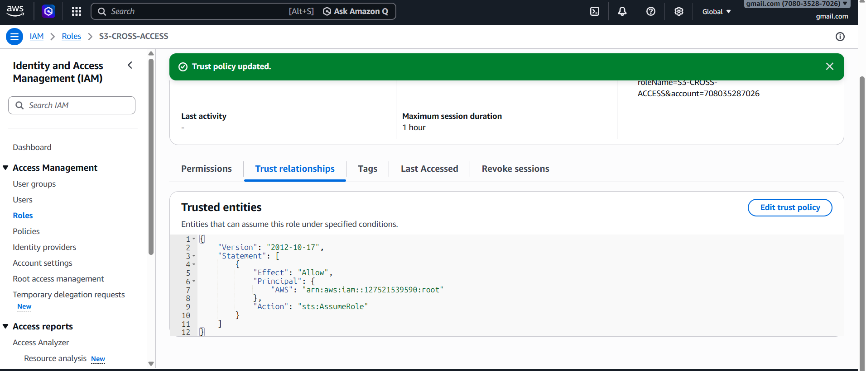
2. Key Components
Source Account:
The account that wants access.
Target Account:
The account that owns the resources.
IAM Role:
Created in Target Account. This role contains permissions (example: S3 access).
Trust Policy:
Defines WHO can assume the role.
Permission Policy:
Defines WHAT actions are allowed.
STS (Security Token Service):
Generates temporary credentials.
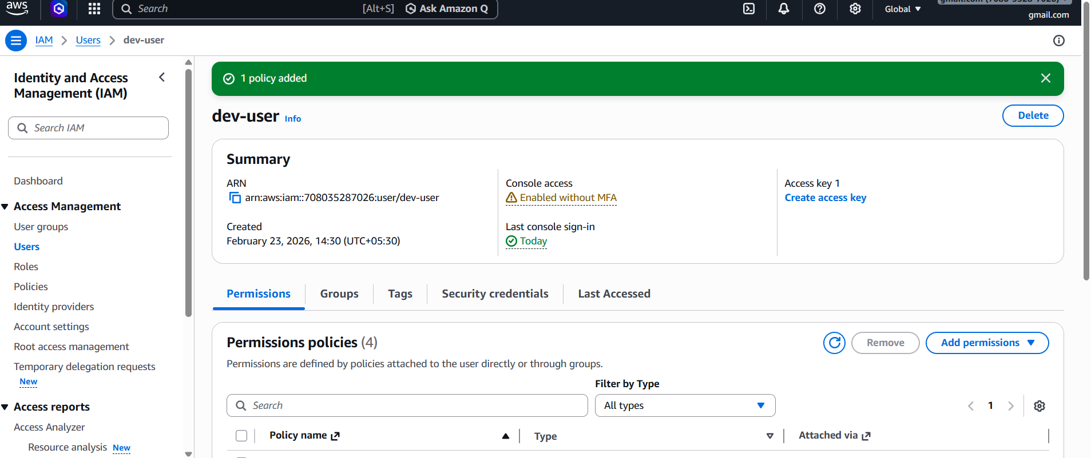

3. Step 1: Create Role in Target Account
Go to:
AWS Console → IAM → Roles → Create Role
Select:
Trusted Entity Type → AWS Account
Enter Source Account ID:
127521539590
Attach permissions:
Example: AmazonS3FullAccess
Role Name:
friend-s3-access
Click Create Role
4. Step 2: Configure Trust Policy
Go to:
IAM → Roles → friend-s3-access → Trust Relationships → Edit
Add:
{
"Version": "2012-10-17",
"Statement": [
{
"Effect": "Allow",
"Principal": {
"AWS": "arn:aws:iam::127521539590:root"
},
"Action": "sts:AssumeRole"
}
]
}
This allows Source Account to assume the role.
5. Step 3: Add Permission in Source Account
Go to:
IAM → Users → Select user → Add Inline Policy
Add:
{
"Version": "2012-10-17",
"Statement": [
{
"Effect": "Allow",
"Action": "sts:AssumeRole",
"Resource": "arn:aws:iam::708035287026:role/friend-s3-access"
}
]
}
This allows user to assume the target role.
6. Step 4: Assume Role using AWS CLI
Command:
aws sts assume-role \
--role-arn arn:aws:iam::708035287026:role/friend-s3-access \
--role-session-name test
This generates temporary credentials.
7. Step 5: Export Temporary Credentials
export AWS_ACCESS_KEY_ID=XXXX
export AWS_SECRET_ACCESS_KEY=XXXX
export AWS_SESSION_TOKEN=XXXX
8. Step 6: Verify Access
aws sts get-caller-identity
Output should show Target Account ID.
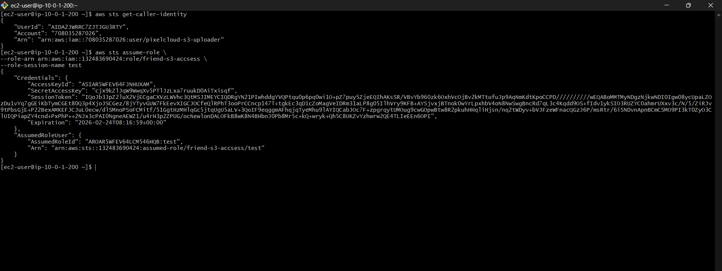
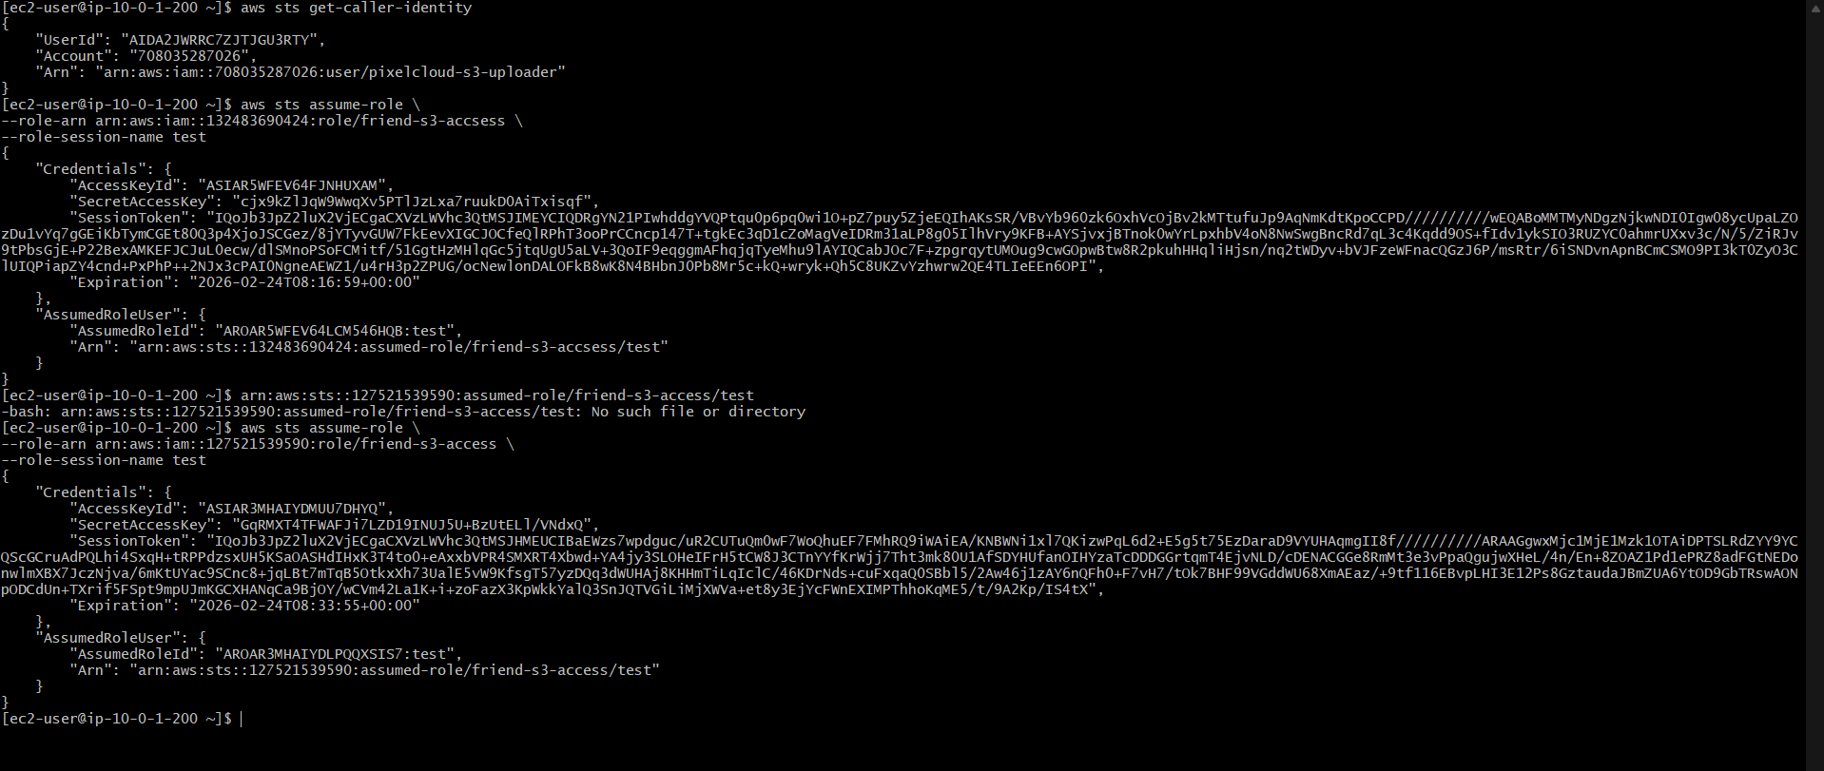

Result:
User in Account A can access S3 bucket in Account B.
1) Common Errors
Access Denied:
Missing trust policy or permission policy
Invalid Credentials:
Wrong export of temporary credentials
2). Security Advantage
No need to share permanent credentials
Uses temporary credentials
More secure access control
Conclusion
• IAM user creation
• Group management
• Policy management
• Automation using bash
• Custom policies
• Cross account access

